Yale International Policy Competition
A Brief Report

Name of the Event: Yale International Policy Competition
Date of the Event: February 7, 2020 - February 9, 2020
Location of the Event: Yale University, New Haven, CT.
Number of Participants: 4
Who Participated: Moses Addai [‘22], Mary Amde [‘20], Bikash Gupta [‘20], Thuy Le [‘22]
Sponsoring Organizations: International Studies Concentration, Social and Behavioral Sciences Concentration, Soka Student Union
Contact Name: Bikash Gupta (SBS), Thuy Le (INTS)

What was the Competition About?

Yale International Policy Competition, which resembles a hybrid of hackathon and Model United Nations, is a student-led policy event at Yale University. Students form groups of four and take part in the one and half-day event, where they write one-page policy briefs on an assigned topic and present their briefs to a group of policy experts. Based on groups’ performance in writing policy briefs and presenting them, the judges chose the top three groups and award them cash prizes worth $1000, $500, and $300.

This year the topic was “Natural Disasters Response and Management in the Caribbean.”

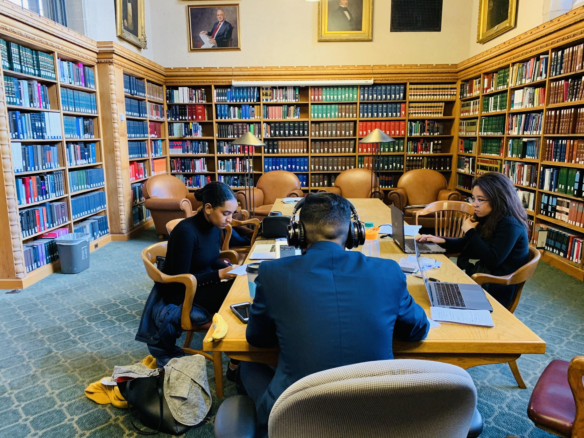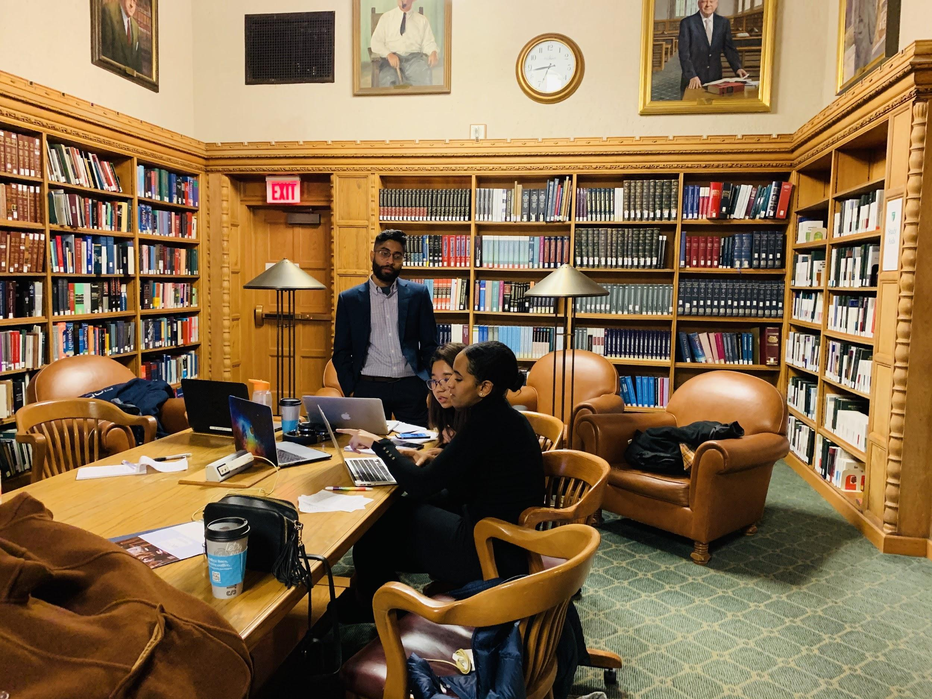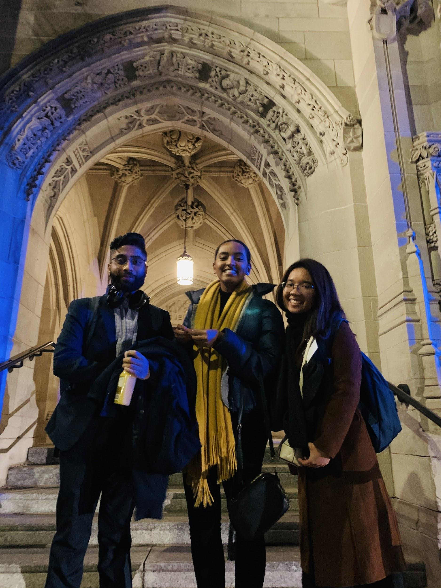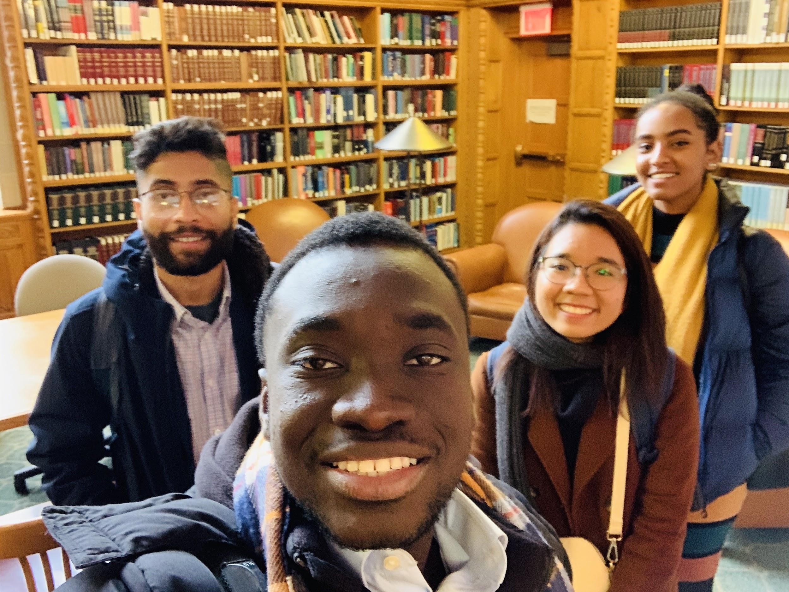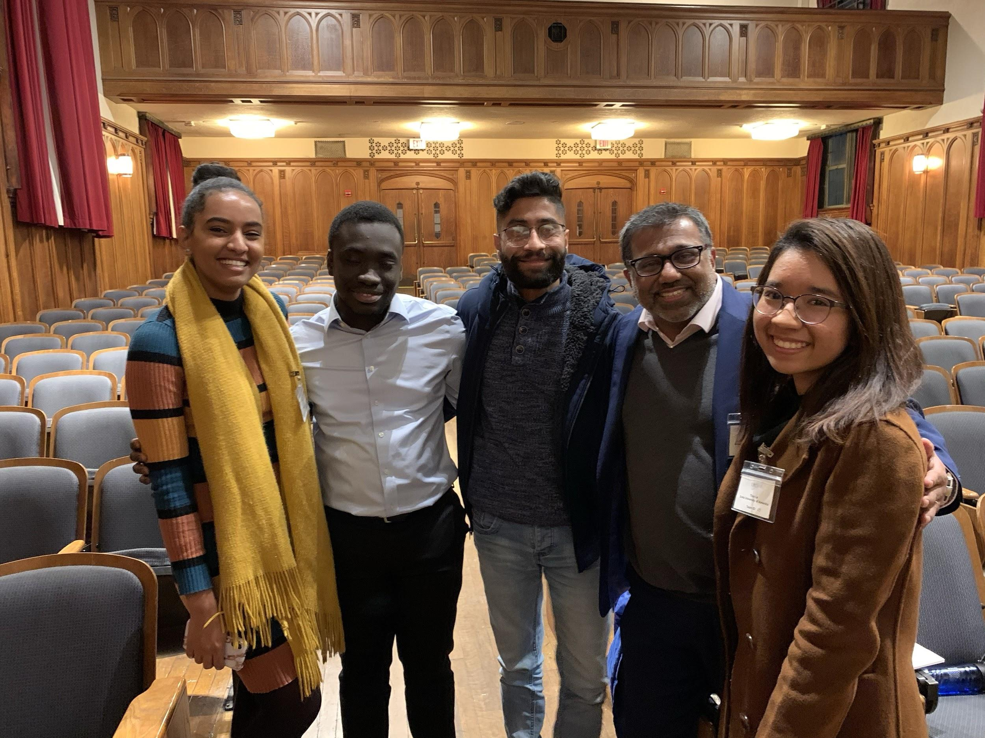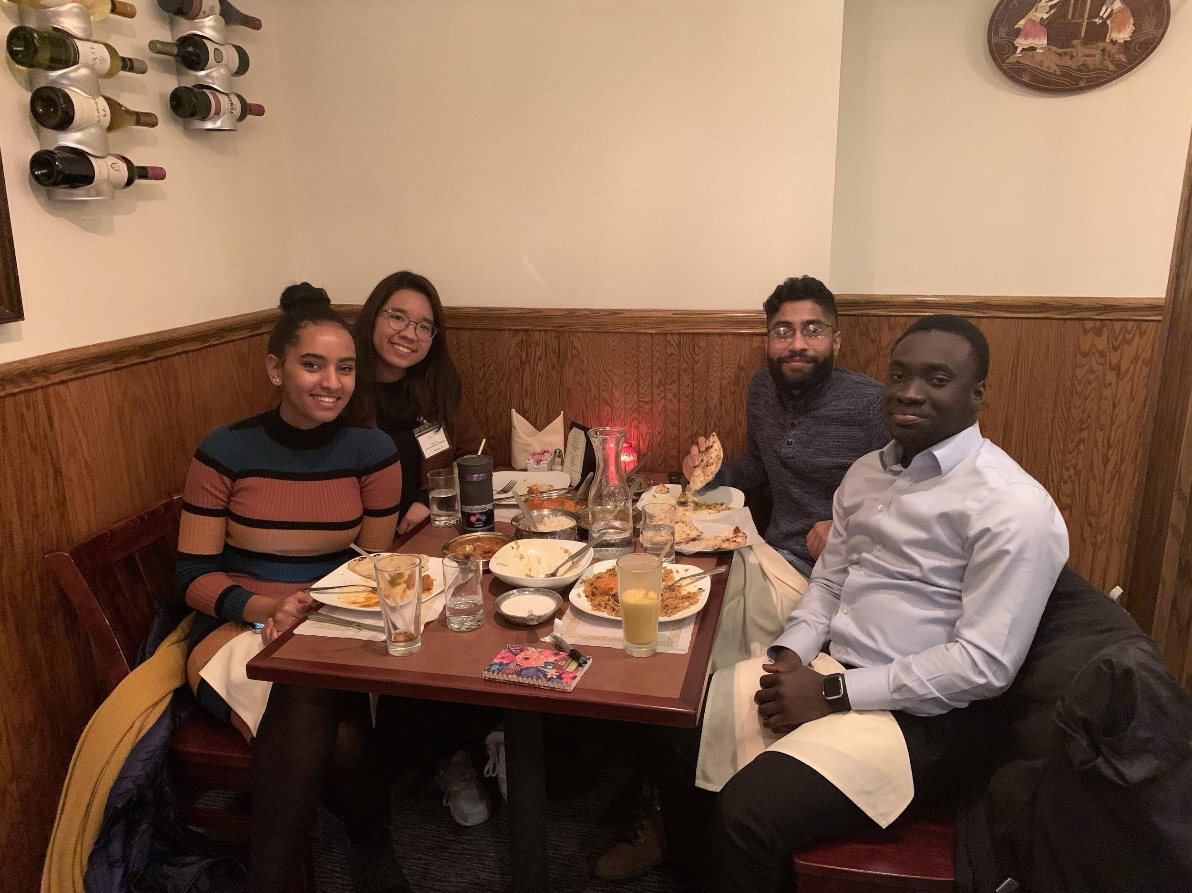

Figure: Some snapshots of the event at Yale.

Takeaways from the Event:

Moses Addai:
I had zero experience in policy writing before I participated in the Yale International Policy Competition (YIPC). I also had little knowledge about the policy-making process and of different stakeholders that shape the process. Even though I have always been excited about devising solutions to the problems at the interface of politics and economics, I did not have working techniques to devise exact solutions. Through the YIPC, I learned the strategy to organize my thoughts and find solutions to complex policy problems.
The competition also presented an exciting challenge for our group. Before the event, we had a couple of meetings to discuss various approaches that we thought could come handy at the contest. We anticipated the policy challenges would be related to some burning issues on the geopolitical and security challenges in South East Asia or the Middle East. However, the topic for the competition turned out to be on disaster management and recovery efforts in the Caribbean. Even though the topic was not what we expected, it allowed us an opportunity to learn about the Caribbean and the challenge the region faces. We also learned to collaborate and co-write a brief together. We all developed fantastic strategies to address the topic but due to the one-page requirement, we had to choose some policies over others. This tactic was done to ensure we produced the best we could given the page constraint.
In all, I gained valuable experience in policy writing and in teamwork that I believe will be of immense benefit moving forward.

Maryamawit Amde:
On the first morning of the competition, my teammates and I exchanged our predictions of what the topic would be, while we nervously sat and waited in Yale’s Sudler Hall. Our three best guesses where the Kashmir conflict, the Iran nuclear deal, and the Israeli-Palestinian conflict. To our surprise, none of our guesses were right. The YIPC board had chosen “Natural Disaster Recovery and Management in the Caribbean” as the topic. From that point on, we had 12 hours to come up with an innovative and feasible policy memo as well as an 8-minute pitch. Our first challenge was to get ourselves familiar with the current Caribbean natural disaster management policies. After doing so, we decided to address our policy memo to the Caribbean Disaster Emergency Management Agency (CDEMA) and the Caribbean Community (CARICOM or CC). Our next and biggest challenge was deciding on what specific problem our policy memo would tackle.
With our team’s diverse backgrounds and interests, each of us had a different idea on what route to take. Bikash believed that our policies should target the low GDP of Caribbean countries. He suggested debt relief, collective insurance and private-public partnerships among Caribbean states. Thuy proposed that our policies should aim to create more trust and collaboration among Caribbean countries. She recommended a multilingual shared database for natural disaster information sharing and family tracking and registry. Moses pushed for policies aimed at increasing employment and businesses. He suggested reduced taxes for home-improvement and generator companies as well as better enforcement of building codes. I favored policies that would protect disaster displaced people. I proposed special visa and work permit provisions for climate refugees among Caribbean countries and better social integration efforts by host countries. I was impressed by how we each managed to come up with unique solutions. But at the same time, I was worried about our one-page limit.
We spent almost three hours debating on which policies to adopt. I struggled to accept the effectiveness of economy-based policies while some of my teammates struggled to see the capacity of immigration law-based policies. Fortunately, we were able to consult with Professor Busenberg over Skype. After that discussion, we decided to take an interdisciplinary approach and incorporate each of our unique ideas. Although this decision would later become the main criticism we received from judges, I believe it was what made our policy memo stand out. Our interdisciplinary approach was also reflective of our multifaceted group.
Throughout the brainstorming and writing process, my biggest concern was time. So early on, I drafted a schedule for us to follow. However, due to the excitement and complexity of the unanticipated topic, we did not follow the proposed schedule. I did not want my worry about our time limit to affect my teammates’ process but I struggled to hide it. Luckily with laughs and group breathing exercises, my teammates made the whole process enjoyable.
Even though none of us had worked with each other on a group project before YIPC, we quickly built a fantastic group dynamic. We joked that Thuy and I were the realists while Bikash and Moses were the idealists. We constantly questioned and checked each other on our policies and sometimes even on our campus navigation skills. English is not the first language to any of us, so there were many misinterpretations but also along were many patient explanations. I am truly grateful for how this experience went and what I was able to take away from it. Thank you to my teammates, the IS concentration and the SBS concentration for making this opportunity possible.

Bikash Gupta:
I learned to write a one-page policy brief. Even though I had taken a public policy class at Soka and learned to write long policy papers, I found it difficult to write one-page policy briefs. It was challenging to truncate so much of information and provide actionable solutions within the space of 8’ * 11’ paper.
We were assigned a topic that was inherently broad. Students could approach the topic “Natural Disasters Recovery and Management in the Caribbean” through the lens of a particular territory within the region, a specific country, or through a single disaster. Coming from various academic backgrounds, we all tried approaching the issue through different thematic lenses and attempted to incorporate everyone’s views. We spent a lot of time trying to take a specific policy stance. The whole process of consensus writing was illuminating because it informed me about the importance of strategic compromise needed to achieve the optimum team result.
Personally, I learned the need to be self-critical in choosing my stances. For example, during multiple times when my friends asked me for clarification on certain stances, I could not muster enough solid reasons. Policy-making stands on evidence and not on hunches, I internalized. I also learned the idea of “thinking less” and “thinking relevant.” There is so much information in the world to always feel like an inadequate researcher. To reduce the focus area to solving a particular problem is an art, which I felt I needed to master.
YIPC brought me closer to amazing people within and outside of my group to which I am grateful. By participating in the competition, I was able to learn more about myself, my strengths and my weaknesses, and envision actionable ways by which I could evolve into a better researcher and policymaker.

Thuy Le:
Last summer, I was so excited when I learned about YIPC. It was an amazing opportunity to apply the knowledge I learned at Soka to solve real-world problems. In the fall, I reached out to Bikash, Moses, and Mary to form a team to take part in the competition. We were honored to have Professors Lisa MacLeod and Junyi Liu as our concentration mentors and to receive financial support from the Student Union, INTS, and SBS Concentration.
It was a long journey from applying for the grant, preparing for the competition, to drafting policy and presenting our ideas at the Yale campus. The topic, “ Natural Disasters Recovery and Management in the Caribbean," was a new area for all of us. Working on an unfamiliar topic under time constraint was real pressure. We only had 12 hours to research, write policy and prepare for the presentation. Besides, as we came from different backgrounds, we had various interests, which made it difficult to collaborate in the first half. The experience taught me a lot about teamwork and leadership. In classroom space, we tend to reach a compromise and include everyone's opinion. However, in real life, compromising is not always a good thing. The judges commented that we had many great ideas but we did not focus on particular policies and instead proposed all we had. We had to put ourselves in the position of policymakers who had limited resources and time, they advised. Inherently, there is a gap between the ideal classroom and the real world. I learned that strong leadership was essential for the success of teamwork. A great leader should have the ability to coordinate different ideas and maintain a calm disposition even in the most stressful situations.
Moreover, participating in YIPIC allowed me to expose to a larger community of excellent students across the country. This opportunity not only stimulated my intellectual curiosity but also enabled a lot of self-reflection. After YIPC, I had a better sense of how the process of policy-making looked like, and what I needed to work on to prepare for a career as a policymaker.

